Intro2Astro

Assignment Week 1

Assignment 0

Q1. What are your goals for this course?

A1. Following are my goals:

1. Get a working knowledge of how to design/work on a pipeline to do basic processing of images that our 2 Panoptes units take in our campus.
2. Do light curve study on Blaze star and other transits.
3. Also, I want to integrate Mathematics, Technology and Astronomy and design a small workshop/curriculum for my kids in the school to give them exposure to the amazing night sky and its infinite possibilities.
4. How to write Research Papers?

Q2. What topics in Astronomy interest you?

A2. I am interested in studying space-time curvature and exploring the possibility of creating artificial wormholes, as depicted in the movie Interstellar. Additionally, I am keen to investigate more practical approaches to Mars exploration and the potential for establishing a sustainable lunar base. I am also interested in exploring the concept of Black holes and what mysteries it holds inside.

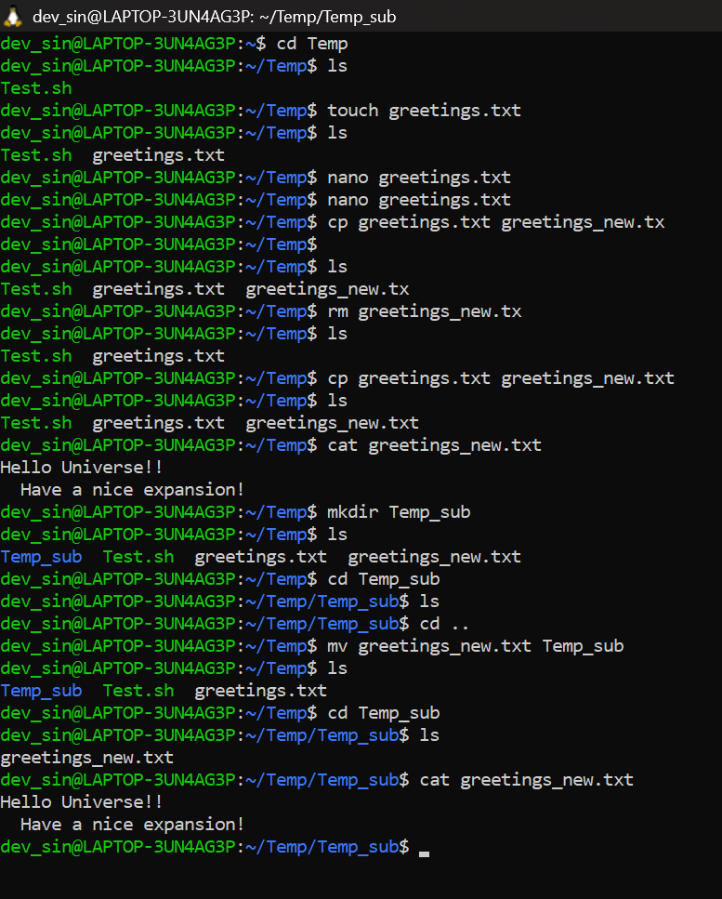

Assignment 1

Unix CLI

1. Creating a new directory
2. Creating and writing a text file
3. Display the contents of the text file
4. Make a copy of .txt file
5. Move it to a new sub directory

***Deliverable (commands that I learned)***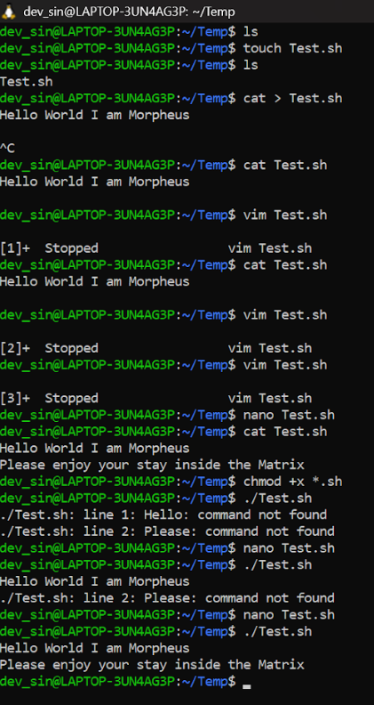

Since we use PANOPTES units in our

Campus, we are pretty familiar with lot of

Unix commands

Assignment 2

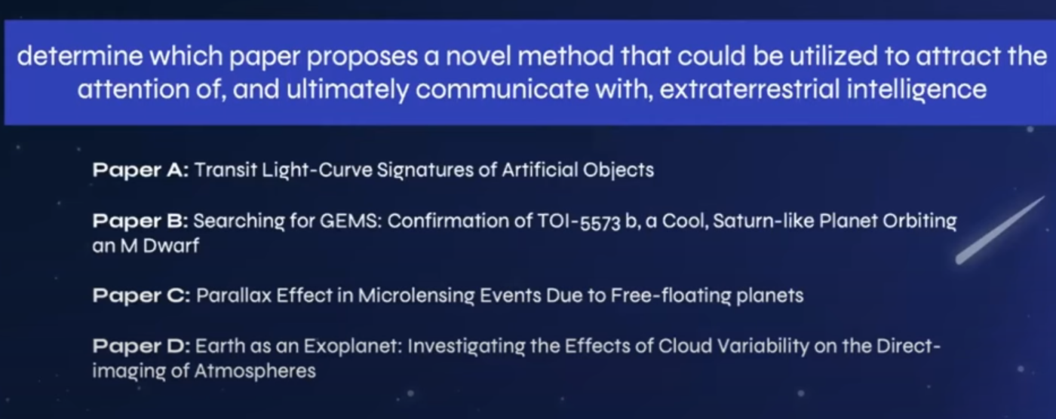

Paper 1 (T**ransit Light-Curve Signatures of Artificial Objects"** by **Luc Arnold**) talks about Search for Extraterrestrial Intelligence (SETI ).

In this paper Mr. Luc says that if something not shaped like a planet, maybe a big triangle or a space station, goes in front of the star, the dip in the light would look very different from a transiting planet and this would help the scientists or astronomers draw a light curve with a different shape and thus help them identify techno signature for intelligent alien life.